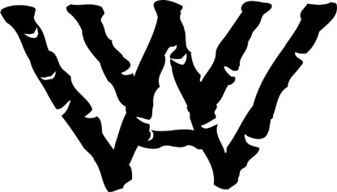Western Writers of America
James Ersfeld Symposium
Dodge City, KS
October 7 & 8, 2016

Dodge City Public Library * 1001 N. 2nd Ave. * Dodge City, KS 67801

Registration Form

Name________________________________________________________________________________________

Address______________________________________________________________________________________

City/State/Zip__________________________________________________________________________________

Phone ______________________________ E-Mail________________________________________________

Pre-registration must be received by Sept. 30, 2016. All other registrations must be made in Dodge City.

ITEM Price Quantity Total
Friday Oct. 7, Evening Session, $0 ____ $ 0
Saturday, Oct. 8 Session $50* _____ $______

TOTAL: MAKE CHECK PAYABLE TO WWA $______

Mail registration WITH check to: Western Writers of America, 271 CR 219, Encampment, WY 82325

Address questions to wwa.moulton@gmail.com (307-329-8942)

All refunds will be assessed a 10% administrative charge. NO Refunds after Oct. 1, 2016

*There is no registration charge for youth writers ages 12-18

Lodging: Best Western Plus Country Inn & Suites, 506 N 14TH, DODGE CITY, KS 67801
Reservations: (620) 225-7378; ask for Western Writers of America room block

